Brassington Parish Council
Notice of conclusion of audit
Annual Governance & Accountability Return for the year ended 31 March 2018
Sections 20(2) and 25 of the Local Audit and Accountability Act 2014
Accounts and Audit Regulations 2015 (SI 2015/234)

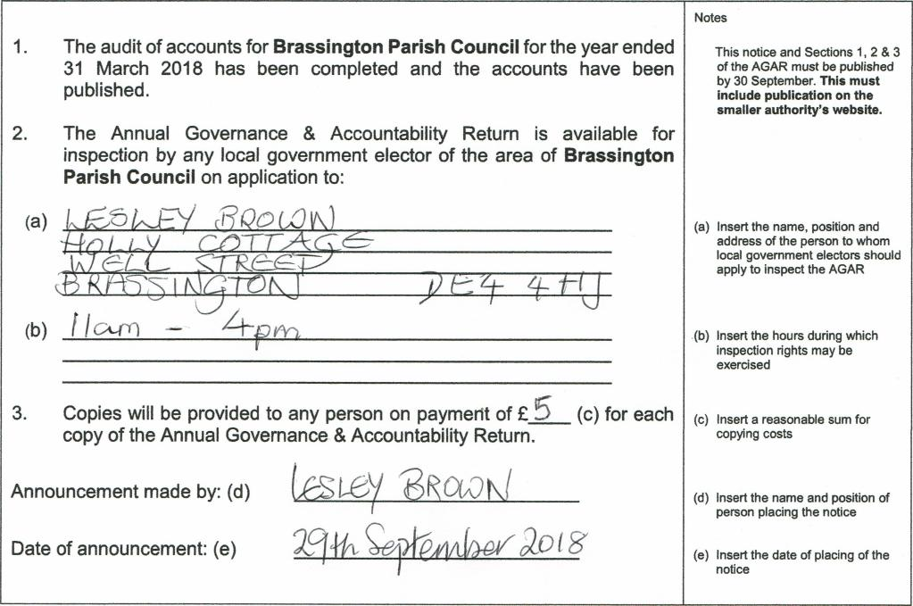
(a
Announcement made by: (d)
Date of announcement: (e)
L,eSLE/ ao0K/
2-9*-Ce,-⁻e⁻emAki0201³/
- The audit of accounts for Brassington Parish Council for the year ended
31 March 2018 has been completed and the accounts have been published.
- The Annual Governance & Accountability Return is available for
inspection by any local government elector of the area of Brassington Parish Council on application to:
(b) f IcA4-0
- Copies will be provided to any person on payment of E (c) for each
copy of the Annual Governance & Accountability Return.
Notes
This notice and Sections 1, 2 & 3 of the AGAR must be published
by 30 September. This must include publication on the smaller authority's website.
- Insert the name, position and

address of the person to whom
local government electors should
apply to inspect the AGAR
- Insert the hours during which
inspection rights may be
exercised
- Insert a reasonable sum for
copying costs
- Insert the name and position of
person placing the notice
- Insert the date of placing of the
notice

